WEBSITE SPECIFICATIONS
The objective of the website is to promote Audi’s brand and vehicles while providing customers with detailed information about their products and services. The goal of the website is to showcase Audi car models with features, prices and specifications, increase sales by encouraging users to book test drives or make inquiries, strengthen brand image by highlighting innovation, luxury, and performance and to provide customer support information such as locations, contact details, and services.

The target audience is expected to have a good level of digital literacy. They should be comfortable navigating through the websites, comparing products online, and completing forms. They expect a modern, responsive, and user-friendly interface from the website. We expect our customers to be middle to high-income professionals aged 25 – 55 years old. They are likely to research deeply online before making a purchase.

The proposed website is primarily a commercial business website. However, it includes some e-commerce features such as booking services and product customisation, rather than operating as a full online shopping platform.. The website will provide users with high, quality videos and images to improve user engagement, interactive features such as forms for test drives and contact information and dealership details.

INFORMATION DESIGN AND TAXONOMY

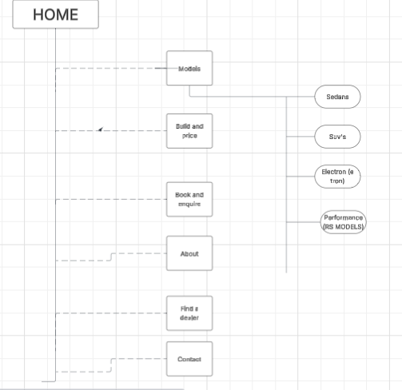

TECHNICAL BRIEF
The website will be developed using modern web technologies to ensure it is responsive, visually appealing, and user-friendly. The core structure of the site will be built with HTML5, while CSS3 will be used to style the layout, colors, and overall appearance to match the premium branding of Audi. JavaScript will be included to add interactivity, such as image sliders and dynamic content. To make the design responsive across different devices, the Bootstrap framework will be used. For development, Visual Studio Code will serve as the main code editor, while Google Chrome will be used for testing and debugging. Version control will be managed using Git and GitHub to keep track of changes and store the project online. The user interface will be designed using Figma, and images will be edited with Adobe Photoshop to maintain high-quality visuals. Additional design elements such as icons will be sourced from Font Awesome. The website will include high-quality images and videos of Audi vehicles sourced from official or licensed platforms. Finally, the site will be deployed using hosting services like Netlify or Vercel, and a domain name will be registered through GoDaddy to make the website accessible online.

